# ISTIO(SERVICE Mesh)

Service mesh: service manages communication between micro-services

### Challenges of micro-service architecture:

1. How to services know how to talk to each other?

Previous: All the endpoint of service the web server need talk to, must be configured for web server.

Disadvantage: When add a new service, need to add the endpoint of that new service in all the micro-services need to talk to it

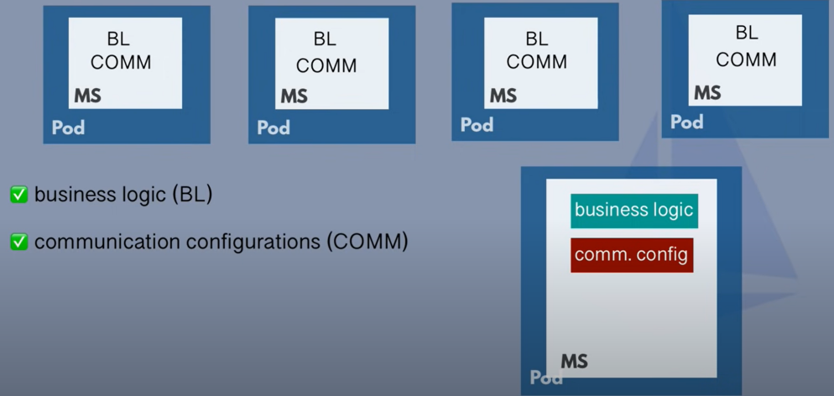

1. Security

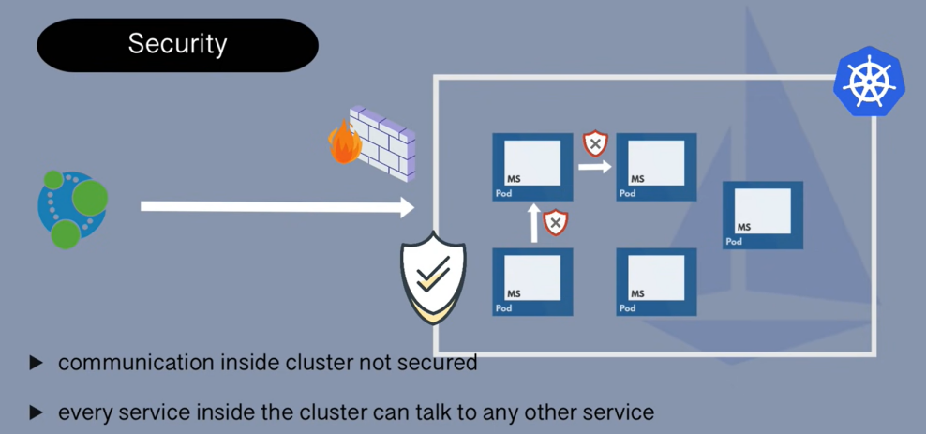

1. Business Logic
2. Retry Logic
3. Metrics & Tracing Logic

For these challenges, if we do not use service mesh, the result will be :

1. These non business logic must be added to each application
2. Developers don’t work on actual service/application logic
3. Adds complexity to the services

### Solution: Service mesh with sidecar pattern

### 

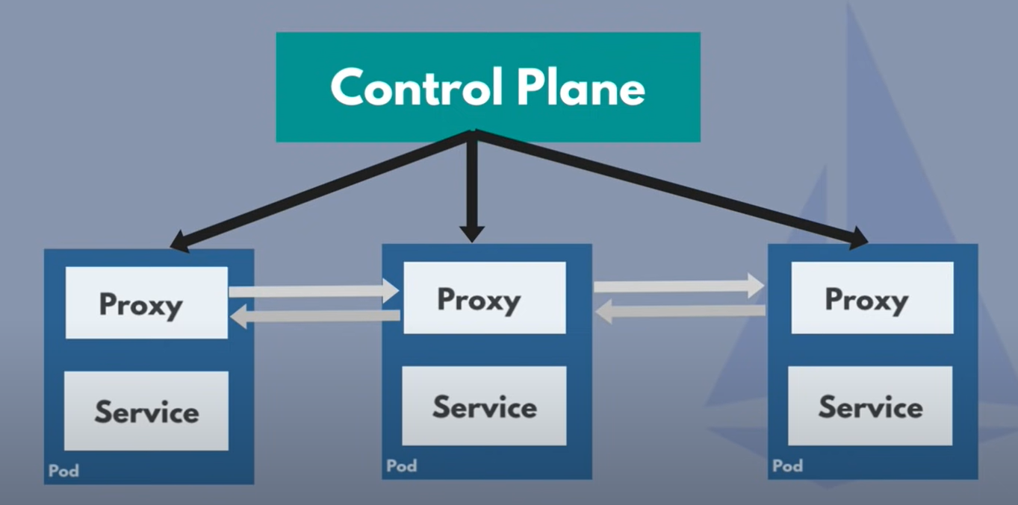

Service mesh control plane will automatically inject these proxy in every micro-service pod

### Service Mesh Core Features

1. Traffic splitting

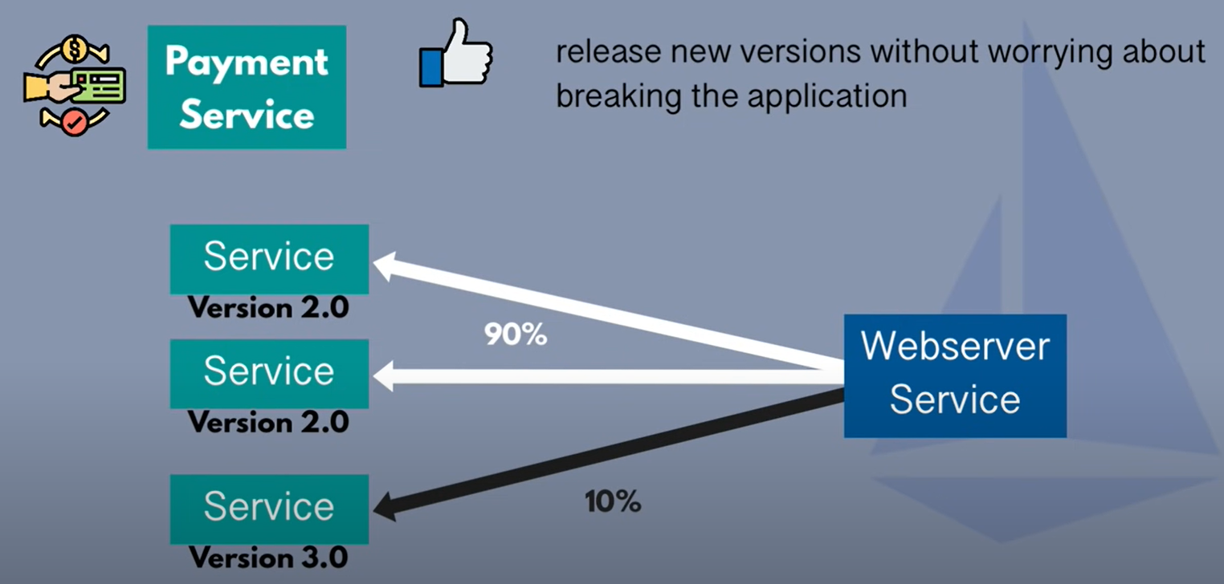

加餐：部署方式

蓝绿部署

特点：同时存在两个集群，两个集群中只有一个集群真正提供服务，另外一个集群测试、验证或待命

优势：服务文档，版本回退简单，适用于各种场景的升级，大版本不兼容升级的或迭代兼容升级

劣势：浪费硬件资源，需要同时有两个集群，如果集群比较大，比如有 1000 个节点，这种方式几乎不可用

金丝雀（灰度发布）

特点：逐点部署，逐步替换线上服务

优势：小步快跑，快速迭代

劣势：只能适用于兼容迭代的方式，如果是大版本不兼容的场景，就没办法使用这种方式了

AB 测试和上面两个不是一个范畴，不做比较。但是需要说明的一点，AB 测试可以采用上面两种部署方式的手法。

1. Dynamic Service Discovery

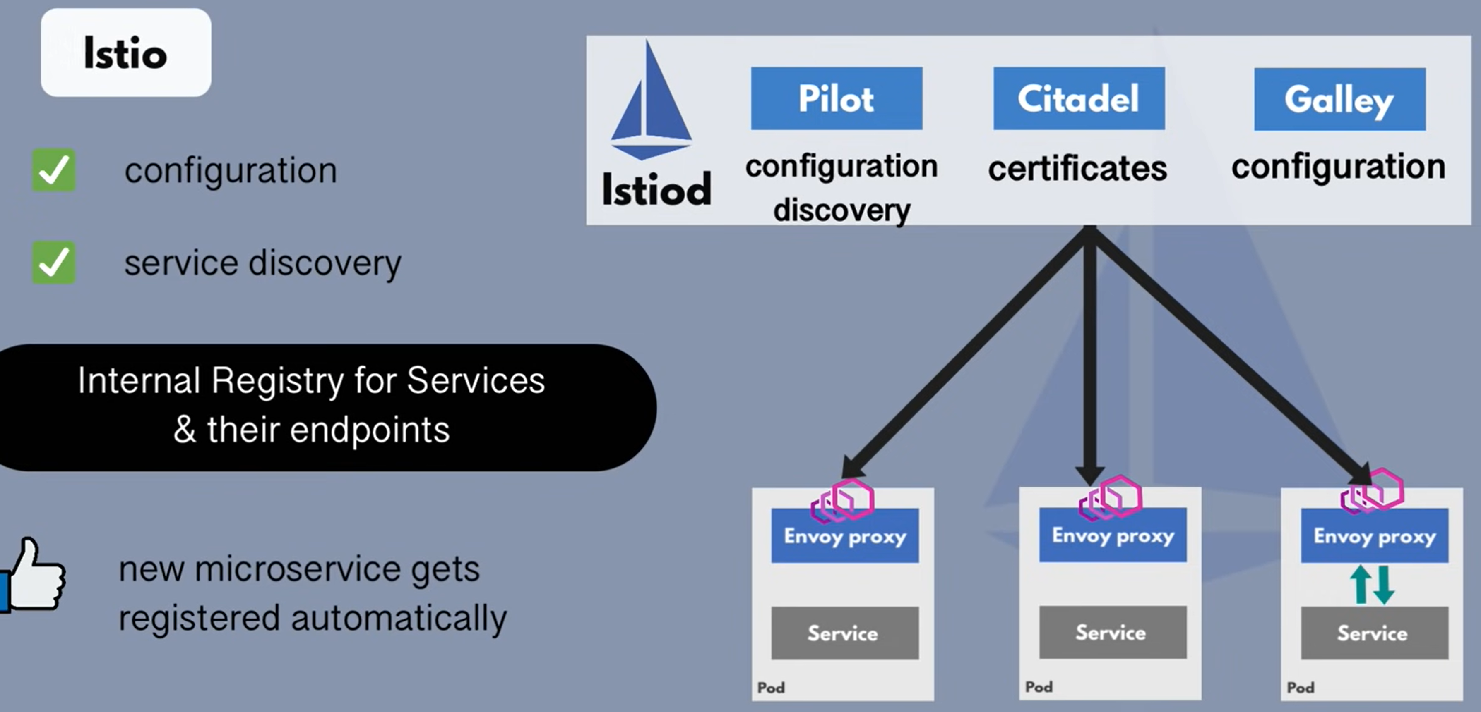

1. Security Certificate Management

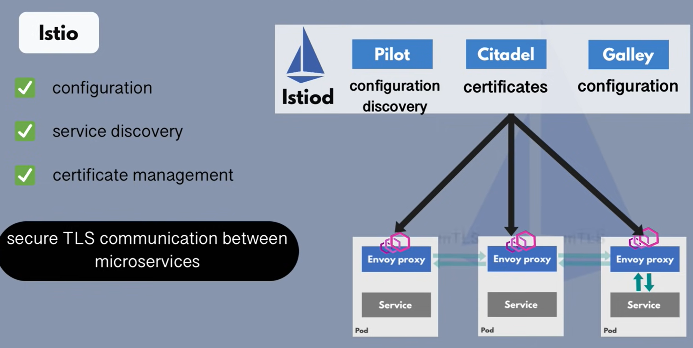

1. Metrics and Tracing Data

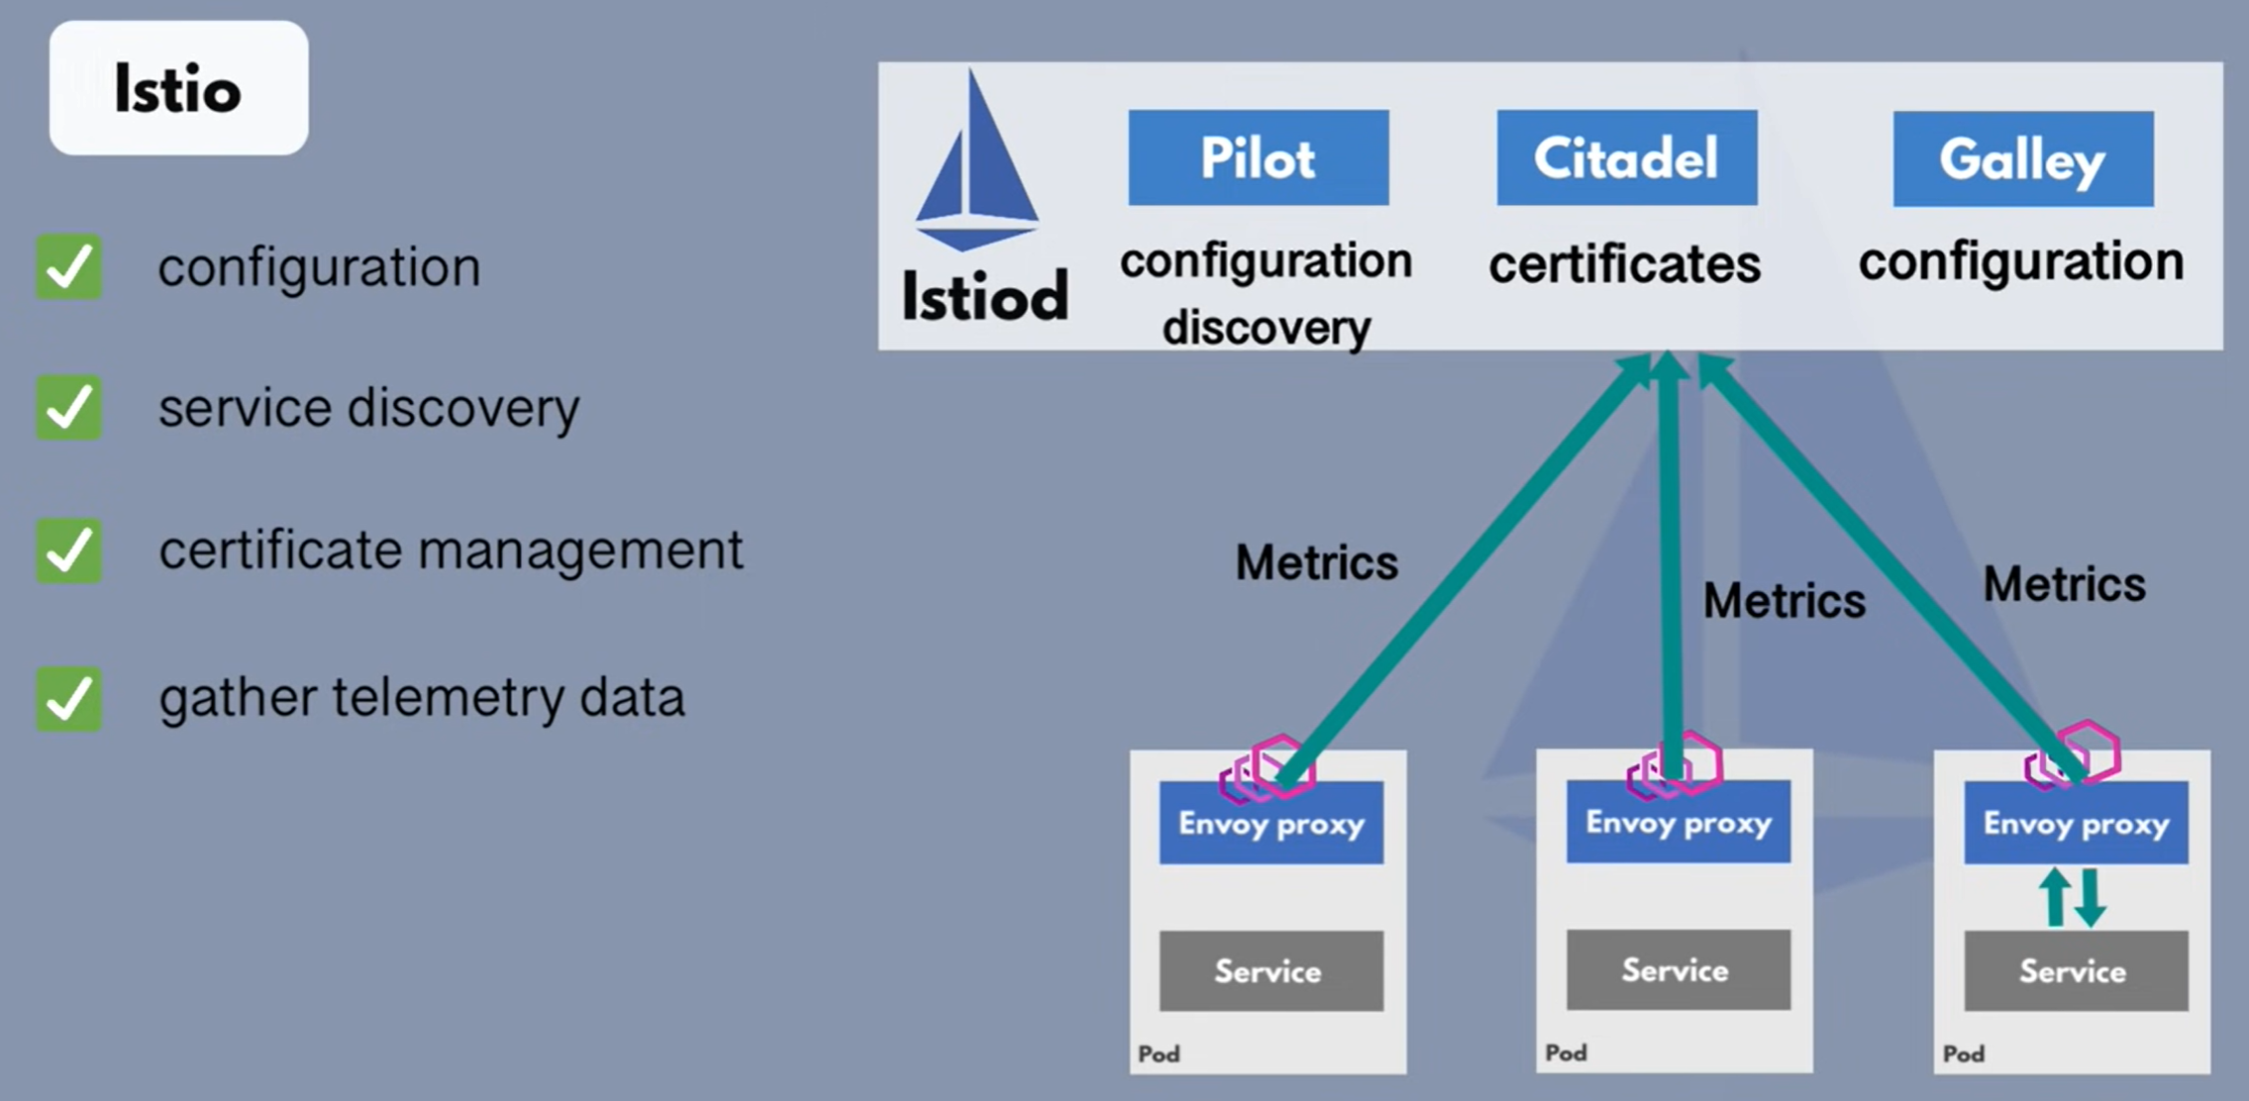

### Istio Architecture

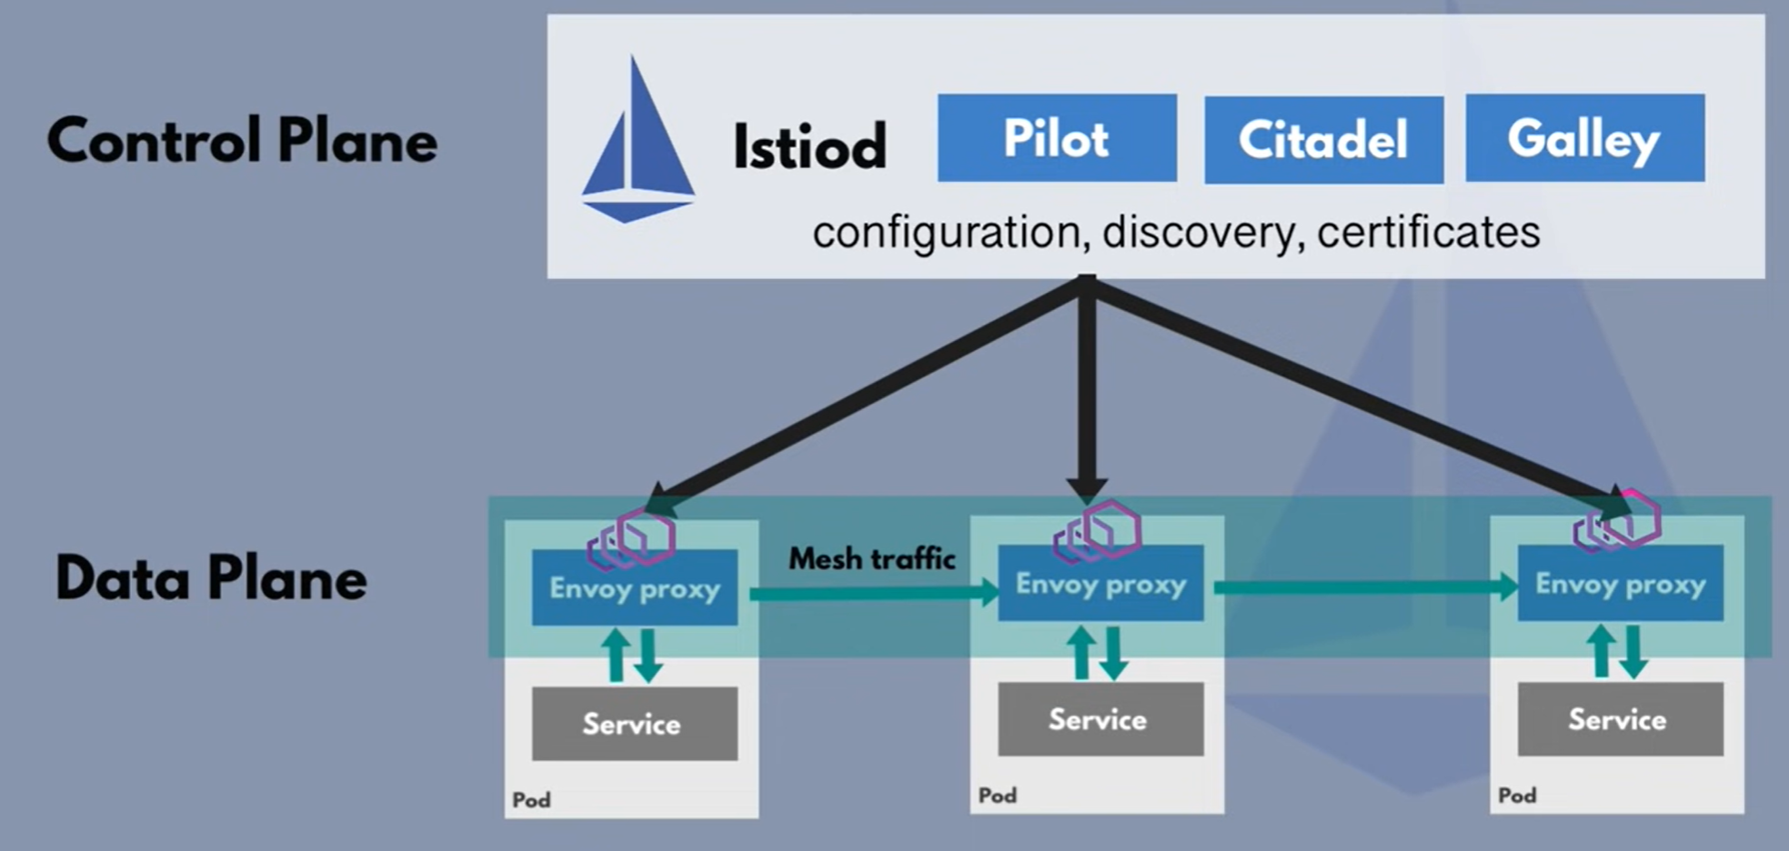

### Istio Configuration

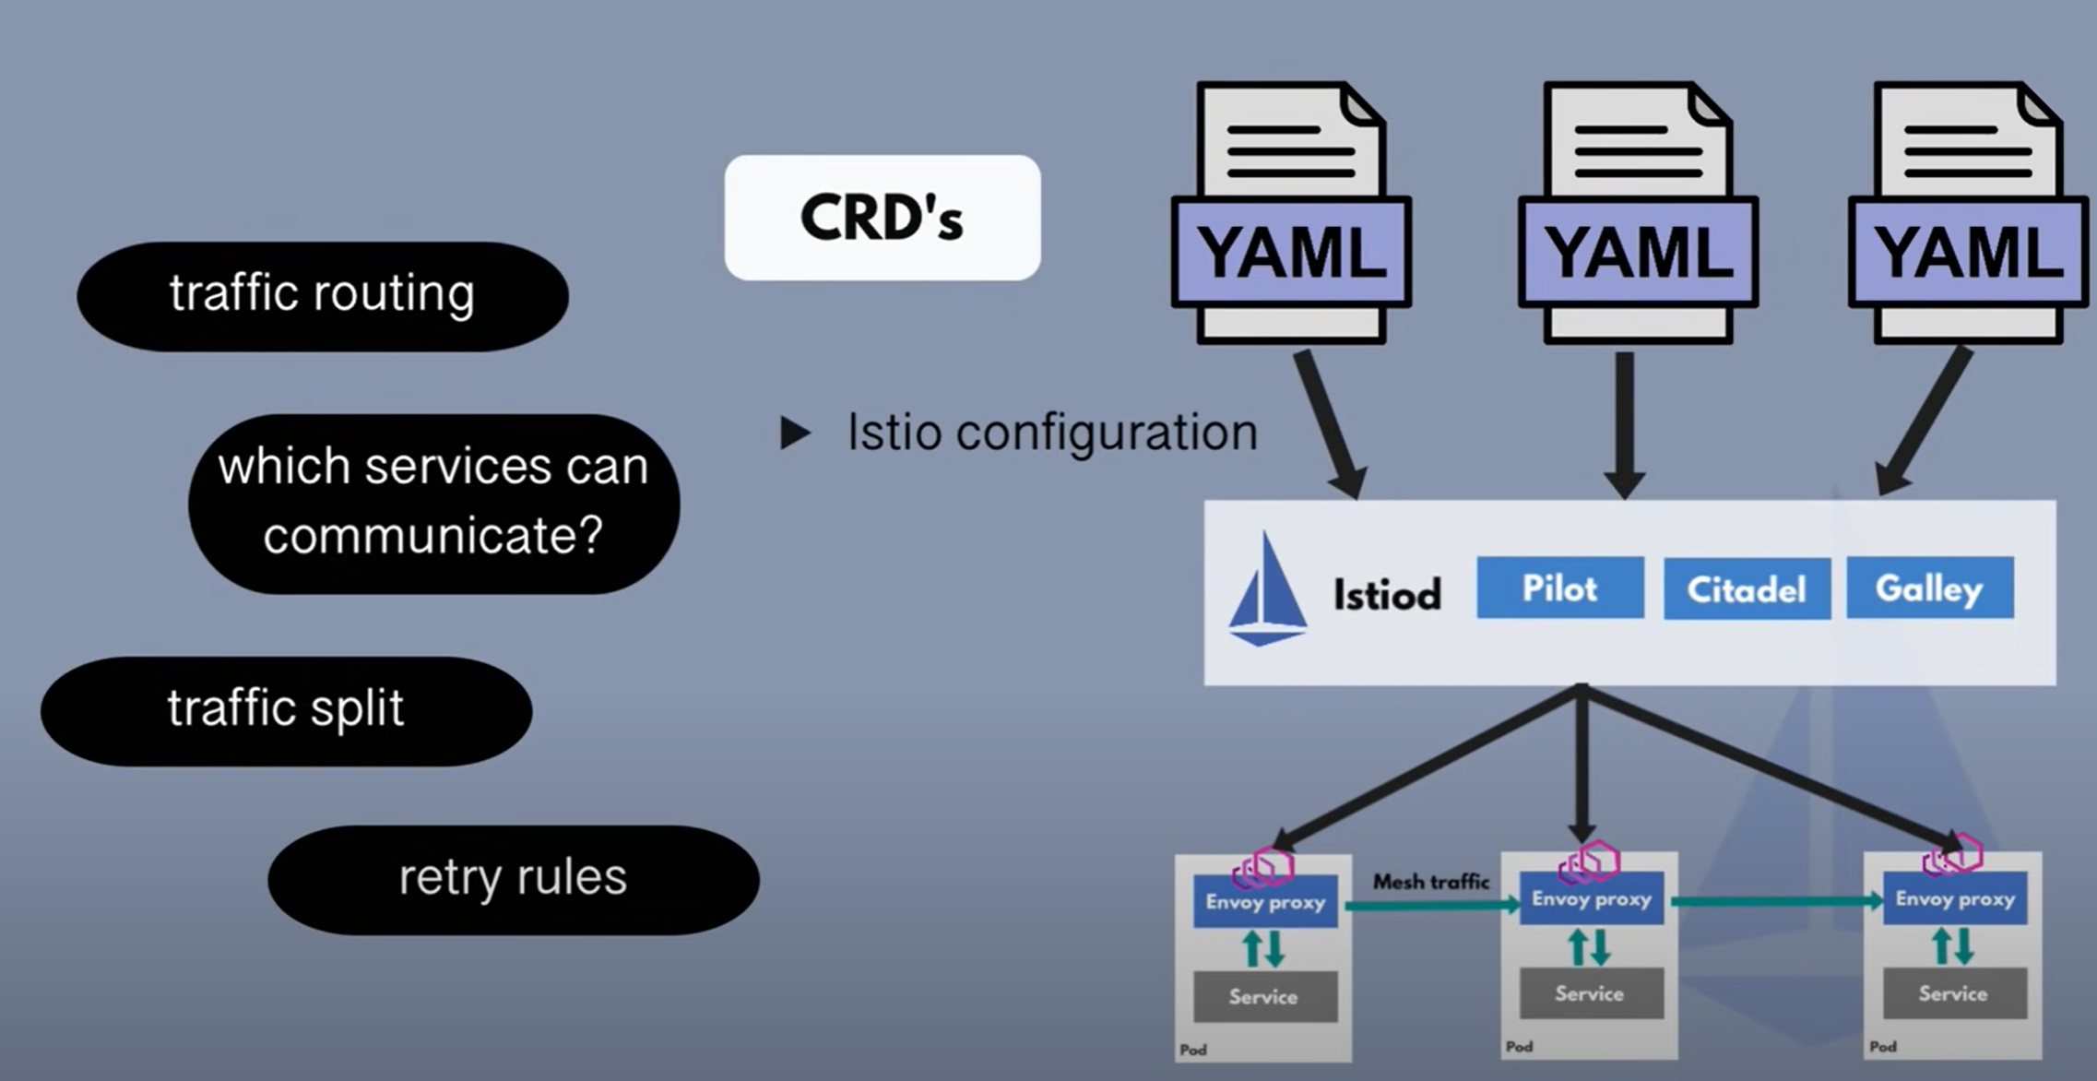

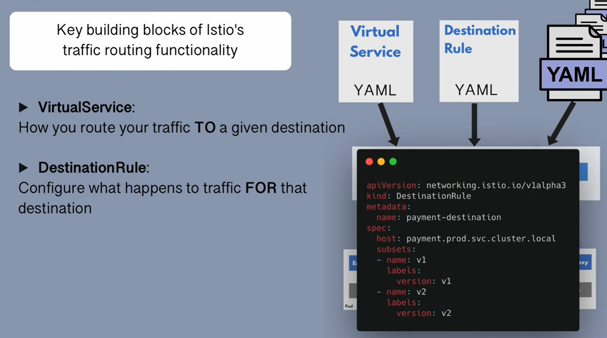

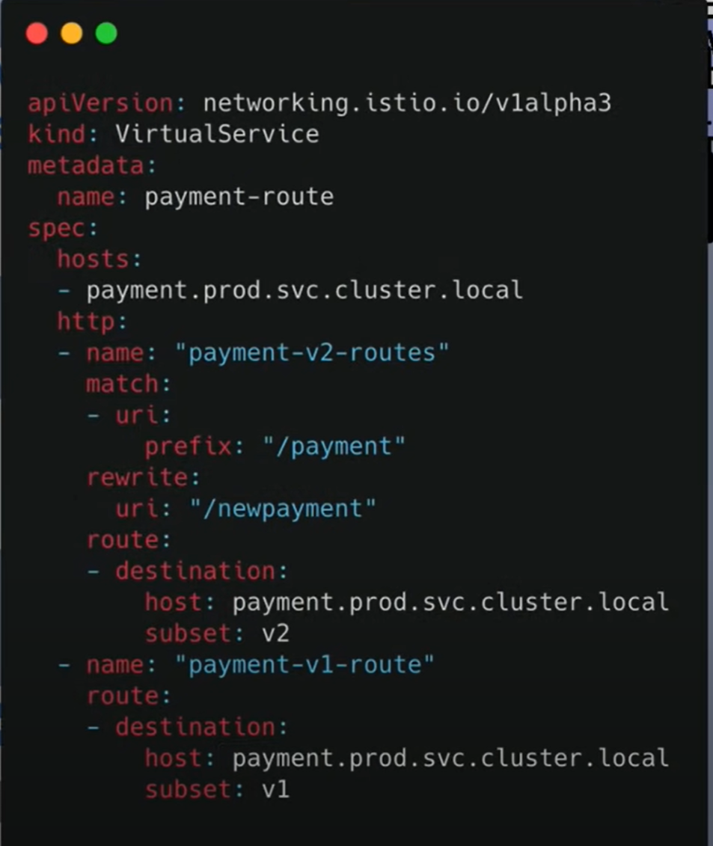

### Istio Gateway

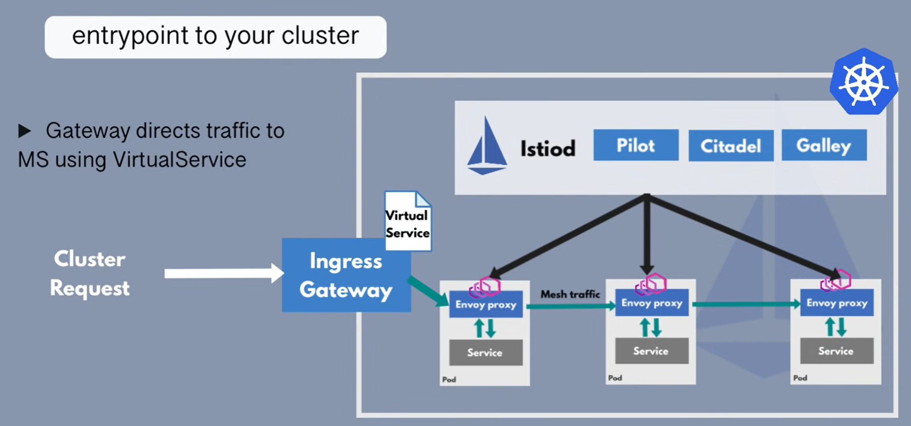

### Traffic Flow

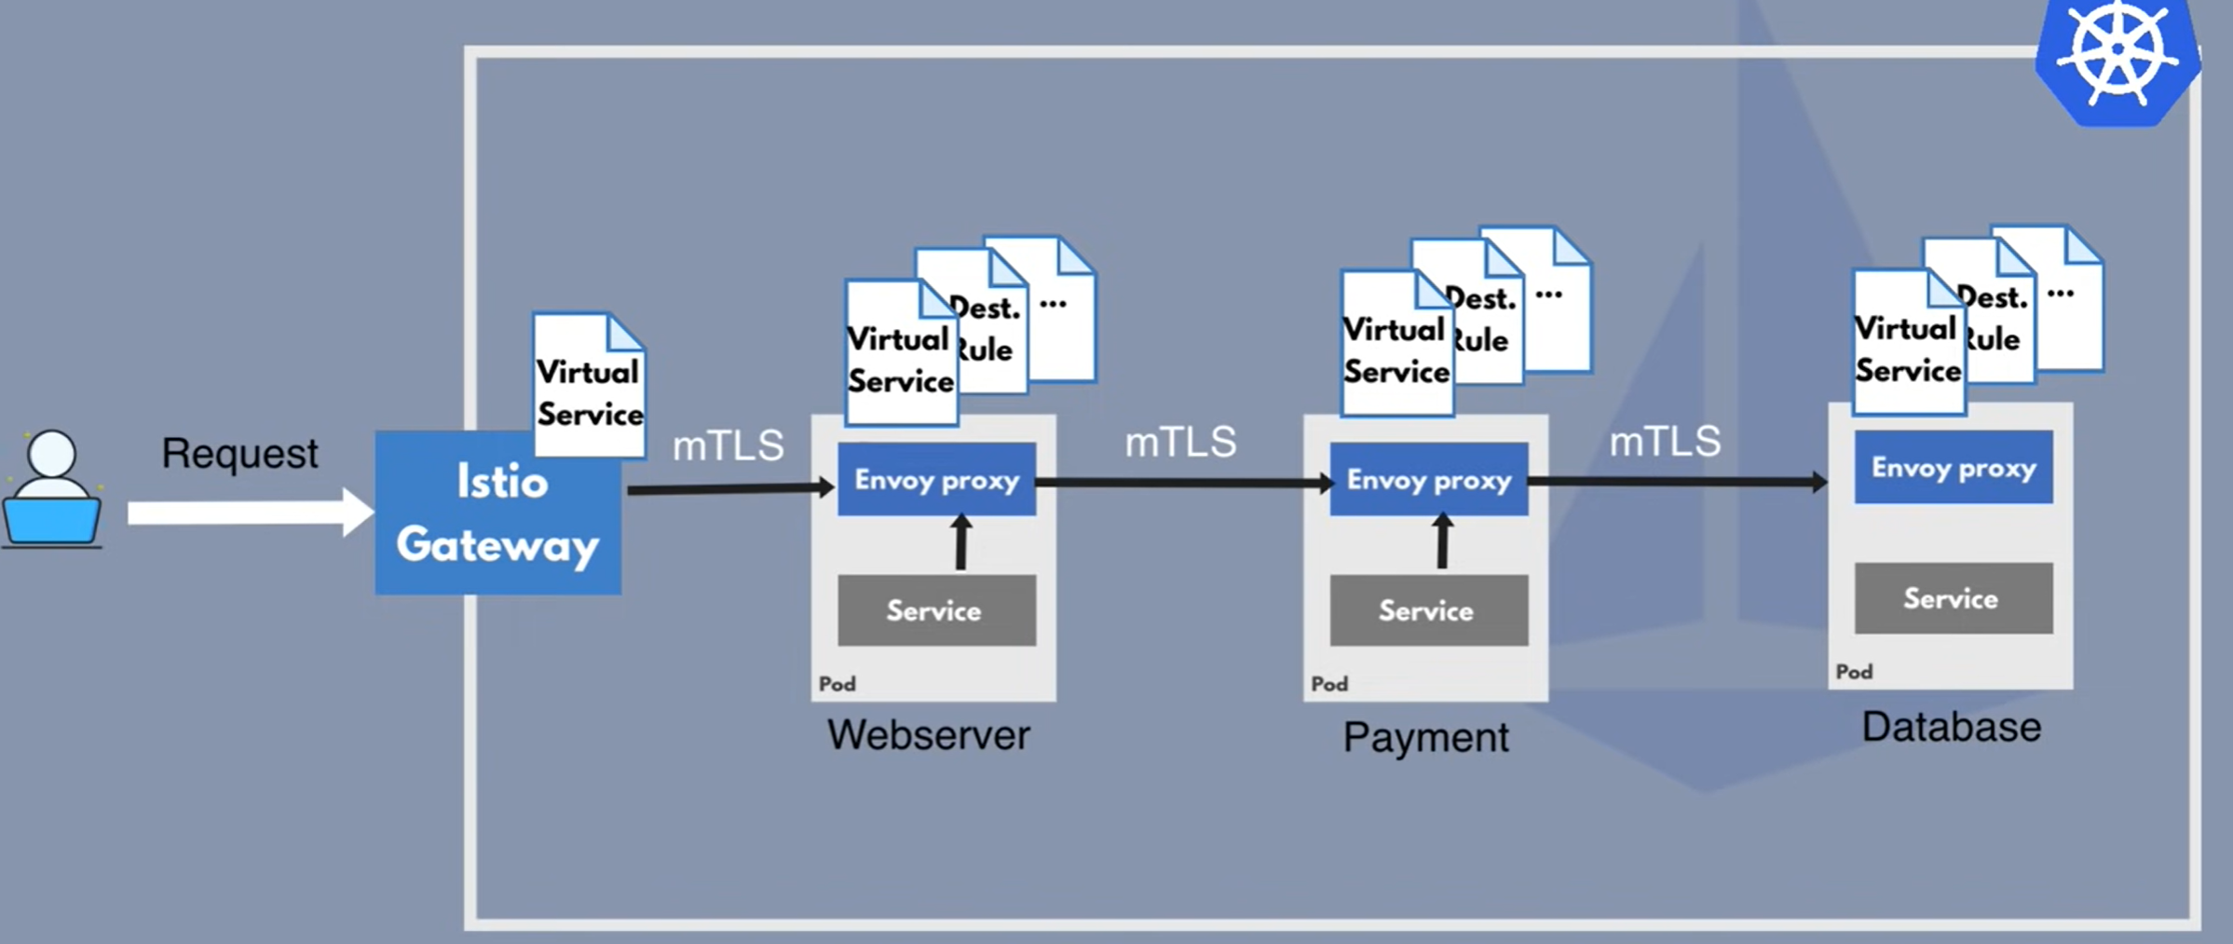

During this traffic flow, proxy will gather metrics and send to control plane

